

**FACE MASK DETECTION OPEN CV USING TENSORFLOW ALGORITHM**

**CAPSTONE PROJECT REPORT**

**COURSE CODE: DSA0212**

**COURSE NAME: Computer Vision with OpenCV for Facial Recognition**

***Submitted by***

1. ***Sai Jagadeesh (192224160)***

***P.Sai Kumar(192224161)***

**ABSTRACT:**

The suggested TensorFlow-based model is trained on a broad dataset that includes pictures of people in a variety of environments and lighting circumstances, both with and without masks. In order to accelerate the training process and enhance model performance, we utilize transfer learning approaches to take advantage of pre-trained CNN architectures, such as Reset and Mobile Net.Data augmentation techniques are used during the training phase to artificially increase the quantity and diversity of the training dataset in order to improve the model's capacity for generalization. In addition, we use methods like dropout regularization to reduce overfitting and boost the model's resilience.Ultimately, the suggested TensorFlow-based mask identification algorithm contributes to the endeavours to curb the spread of contagious diseases in public places by providing a dependable and effective automated mask detection solution.

**Keywords:** TensorFlow,CNN architectures, ResNet, MobileNet, data augmentation, mask identification algorithm, automated mask detection solution.

**INTRODUCTION:**

Conventional techniques for mask recognition frequently rely on labour-intensive, prone to error, rule-based algorithms, or manual inspection. These approaches also have limited scalability. Convolutional neural networks (CNNs) and frameworks like TensorFlow are being used to create more precise and effective mask identification algorithms as a result of developments in deep learning and the accessibility of large-scale datasets.

The growing significance of mask wear has sparked interest in creating automated mask detection systems to guarantee adherence to public health recommendations. These systems use deep learning and computer vision techniques to examine photos or video feeds and evaluate whether or not people are correctly donning masks.

In this paper, we use TensorFlow, a well-liked deep learning framework created by Google, to provide a unique method for mask identification. Our system seeks to reliably detect people wearing masks in photos or video streams so that mask-wearing regulations can be automatically monitored and enforced in different contexts.

**STATEMENT OF THE PROBLEM:**

The necessity of using face masks as a preventive measure to reduce the spread of respiratory viruses in public areas has been highlighted by the COVID-19 pandemic. For authorities and businesses, however, enforcing compliance with mask-wearing standards is a substantial challenge. Mask usage monitoring by hand is time-consuming, error-prone, and frequently not scalable in areas with heavy foot traffic.

The current mask detection techniques—manual inspection and rule-based algorithms, among others—are insufficient for real-time policy enforcement and monitoring regarding the wearing of masks. While rule-based algorithms might not be flexible enough to adjust to different settings and differences in mask kinds and wearing methods, manual inspection is inefficient and prone to human mistake.

This study's main goal is to overcome the shortcomings of current techniques by creating a reliable and accurate mask detection algorithm with TensorFlow, a deep learning framework. In order to enable automated monitoring and enforcement of mask-wearing policies in public contexts, the proposed algorithm seeks to achieve high accuracy, sensitivity, and specificity in identifying mask-wearing individuals in pictures or video streams.

**NEED FOR THE STUDY:**

Several crucial variables necessitate the development of an accurate and effective TensorFlow mask detection algorithm:

Protection of Public Health: The COVID-19 pandemic has brought attention to the significance of taking preventative steps, such donning face masks, to stop the spread of respiratory illnesses. Enforcing public health regulations and lowering the danger of virus transmission in busy public places, workplaces, and other high-traffic areas can be aided by automating the detection of mask-wearing persons.

Enforcement of Compliance: In order to guarantee adherence to public health rules, governments, corporations, and public institutions have imposed mask-wearing obligations. Large-scale environments make manual mask usage monitoring problematic, making automated solutions necessary for effective enforcement and compliance tracking.

Labor and Resource Savings: Manually checking for mask compliance requires a lot of work and time, as well as specialized staff for enforcement and monitoring. By automating mask detection with TensorFlow, staff members can concentrate on other crucial responsibilities by minimizing the effort and resource needs associated with manual monitoring.

Real-time monitoring: When people wearing masks are detected in real-time, it allows for timely intervention in cases of non-compliance, which increases the efficacy of public health initiatives. TensorFlow-based automated systems are able to continuously scan crowds and instantly notify or alarm anyone who is seen not wearing a mask.

To summarise, the research on TensorFlow-based mask identification highlights the urgent need for automated solutions that can uphold mask-wearing regulations, safeguard public health, and improve compliance monitoring across a range of contexts. This project seeks to develop a robust and efficient algorithm for real-time mask identification by utilizing deep learning techniques implemented in TensorFlow. This will help with the global efforts to tackle the COVID-19 pandemic and future public health concerns.

**SCOPE OF THE STUDY:**

This study on TensorFlow mask detection covers a number of important areas pertaining to the creation, assessment, and possible uses of the suggested technique. The following areas are included in the scope; however, they are not the only ones:

Gathering and preparing data:

* assembling a variety of datasets with pictures or videos of people wearing masks or not in varied environments and lighting circumstances.
* improving the dataset's resilience, balance, and variety through preprocessing and augmentation.

Training and Model Architecture:

* creating a deep learning architecture for mask detection with TensorFlow, possibly utilizing CNN architectures that have already been trained, such Reset or Mobile Net.
* putting transfer learning strategies into practice to speed up training and enhance model performance.
* investigating various regularization strategies, optimization algorithms, and hyperparameters to improve the accuracy and generalization of the model

Assessment of Performance:

* carrying out thorough testing to assess the mask recognition algorithm's TensorFlow-based performance.
* evaluating parameters such computing efficiency, sensitivity, specificity, and accuracy.

testing the algorithm's resilience using a range of datasets, settings, and mask modifications.

The goal of this study is to give a thorough understanding of mask detection with TensorFlow, covering a variety of topics from model creation and assessment to practical deployment issues and moral ramifications. The study intends to address these factors in order to enhance automated mask identification technology and provide insightful information that may have ramifications for public health and safety.

**LITERATURE STATEMENT OF THE PROBLEM:**

Following the global COVID-19 epidemic, academics and practitioners have focused a great deal of emphasis on the mask detection problem, looking for automated methods to enforce mask-wearing rules and reduce the spread of respiratory illnesses. The majority of the material currently in publication on mask detection addresses the difficulties involved with manually enforcing mask-wearing laws in a variety of contexts and monitoring compliance**.**

In situations where there is a lot of foot traffic, manually inspecting mask compliance is time-consuming, prone to mistakes, and not practicable. Although rule-based algorithms offer some automation, they are frequently unable to adjust to a variety of situations and differences in the kinds of masks and how they are used. Furthermore, in dynamic and complicated contexts, standard mask detection techniques like handmade feature extraction or shallow learning models could find it difficult to attain high accuracy and durability.

Convolutional neural networks (CNNs) and frameworks like TensorFlow are being used to create automatic mask identification systems as a result of recent developments in deep learning and computer vision. Despite changes in lighting, facial angles, and mask kinds, these deep learning-based algorithms offer promising solutions for successfully detecting people wearing masks in real-time.

**LITERATURE REVIEW:**

A wide range of academic fields, including computer vision, machine learning, public health, and the social sciences, have produced literature on mask detection. In order to overcome the difficulty of automating mask identification in diverse settings and applications, researchers have investigated a variety of strategies and techniques.

Conventional Approaches: Conventional computer vision techniques and manually developed feature extraction approaches were frequently used in the early stages of mask detection research [1]. In order to identify the existence of masks, these procedures entailed recognizing specific facial regions and assessing texture or color attributes. These methods could not, however, adjust to different kinds of masks, facial angles, or illumination circumstances.

Deep Learning Approaches: Mask detection robustness and accuracy have significantly improved as a result of the development of deep learning, notably convolutional neural networks (CNNs) [2]. Large-scale datasets and CNN architectures that have already been trained are used by deep learning-based techniques to acquire discriminative features for mask detection. To improve model performance, methods like ensemble learning, data augmentation, and transfer learning have been used [3] [4] [5].

The body of research on mask identification shows how methods and approaches have changed over time, moving from conventional computer vision techniques to deep learning-based approaches [6] [7]. More research is needed to create automatic mask recognition systems that are more precise, effective, and morally sound by addressing issues including model stability, real-time performance, scalability, and ethical considerations.

**OVERVIEW:**

Using TensorFlow, a deep learning framework, the project aims to construct an automated mask identification system to solve the difficulties in manually monitoring and enforcing mask-wearing policies in public settings. The suggested method uses convolutional neural networks (CNNs) to precisely identify people wearing masks in pictures or video streams. It may find use in retail settings, public health monitoring, transportation security, and workplace safety.

The study starts with a thorough assessment of the literature, looking at the methods, approaches, and difficulties that are currently being faced in mask detection across a range of fields, such as computer vision, machine learning, public health, and social sciences. The review of the literature sheds light on conventional techniques, deep learning strategies, frameworks, datasets, practical applications, and moral issues surrounding mask detection.

**ANALYSIS OF MARKET:**

Analyse the mask detection solutions market's present size and anticipated expansion. To learn more about the need for these kinds of solutions, look for market research studies, industry publications, and statistical information.

Determine the main trends influencing the mask detection solution market. This could involve things like the rising use of automated technology, the greater focus on public health and safety, and mask-wearing regulations.

Determine which current market participants are providing mask detection solutions in order to analyse the competitive landscape. Analyse their consumer base, pricing policies, distribution methods, market share, and range of products offered.

Recognize the target market segments for solutions related to mask detection. These could include business headquarters, healthcare facilities, retail stores, transportation hubs, and government offices.

**MARKET SIZE:**

Look for industry reports and market research studies published by reputable firms specializing in technology, healthcare, or security sectors. These reports often provide comprehensive analyses of market size, trends, growth drivers, and competitive landscape for specific segments, including mask detection solutions.

The market for mask detection solutions can be segmented based on applications across various industries and sectors. For example, it may include applications in healthcare facilities, retail stores, transportation hubs, educational institutions, corporate offices, and public venues. Assessing the market size for each application segment can provide a more granular understanding of demand and potential opportunities.

**MARKET PROFITABILITY:**

Market profitability refers to the potential for a market or segment within a market to generate profits for businesses operating within it. Evaluating market profitability involves assessing various factors related to the demand, competition, costs, pricing, and potential returns on investment. Here are some key considerations for analysing market profitability in the context of mask detection solutions:

Assess the size of the market for mask detection solutions, considering factors such as the number of potential customers, market segments, and geographic regions. Evaluate the level of demand for these solutions based on factors such as regulatory requirements, public health concerns, and the need for compliance with mask-wearing guidelines.

Analyse the competitive landscape to understand the level of competition within the market for mask detection solutions. Assess the market share and positioning of existing competitors, their strengths and weaknesses, and any barriers to entry. Consider how your offering will differentiate itself and capture market share.

**INDUSTRY COST STRUCTURE:**

The cost structure within the industry of mask detection solutions can vary depending on various factors such as the type of technology used, the scale of operations, and the specific market segment being targeted. However, here is a general overview of the cost structure that businesses within this industry might encounter:

Research and Development (R&D) Costs: Developing and refining mask detection algorithms, software, and hardware components requires significant investment in research and development. This includes costs associated with hiring skilled engineers, data scientists, and researchers, as well as expenses for equipment, software tools, and prototyping.

Technology Infrastructure: Building and maintaining the necessary technology infrastructure to support mask detection solutions involves costs such as cloud computing services, data storage, and computational resources for processing large datasets and running machine learning models.

Marketing and Sales: Promoting and selling mask detection solutions requires investment in marketing activities such as advertising, branding, trade shows, and digital marketing campaigns. Sales costs include expenses related to sales personnel, sales commissions, customer acquisition, and relationship management.

Overall, the cost structure within the industry of mask detection solutions is multifaceted and includes various components related to technology development, regulatory compliance, marketing and sales, customer support, and general operations. Businesses must carefully manage these costs to ensure profitability and competitiveness in the market.

**DISTRIBUTION CHANNELS:**

Distribution channels for mask detection solutions vary depending on the specific market segment, target customers, and business model. Here are some common distribution channels that businesses within the industry of mask detection solutions may utilize:

Direct Sales: Selling directly to customers or end-users is a common distribution channel for mask detection solutions. This approach involves businesses establishing their sales teams or representatives to reach out to potential customers, demonstrate the product, negotiate contracts, and facilitate the sale. Direct sales channels are particularly effective for targeting large enterprises, government agencies, and organizations with specific needs and customization requirements.

Online Platforms and E-commerce: Leveraging online platforms and e-commerce channels is an effective way to reach a wider audience of potential customers. Businesses can sell mask detection solutions through their own e-commerce websites or online marketplaces such as Amazon, eBay, or specialized platforms for technology products. This distribution channel allows for easy access to customers worldwide and facilitates online transactions, product demonstrations, and customer support.

Channel Partners and Resellers: Partnering with channel partners, resellers, or distributors can extend the reach of mask detection solutions to new markets and customer segments. Channel partners may include value-added resellers (VARs), system integrators, technology consultants, or authorized distributors with established networks and expertise in specific industries or geographic regions. Collaborating with channel partners enables businesses to leverage their existing customer relationships, industry knowledge, and distribution networks to promote and sell mask detection solutions.

Referral Programs and Affiliate Marketing: Implementing referral programs or affiliate marketing initiatives can incentivize existing customers, partners, or industry influencers to promote and recommend mask detection solutions to their networks. Referral programs typically offer rewards or commissions for successful referrals, encouraging advocates to promote the product and expand the customer base.

**NEW TRENDS IN THE MARKET:**

There's a growing trend towards integrating mask detection capabilities with access control systems in various industries such as healthcare, transportation, retail, and corporate offices. These integrated solutions not only detect mask compliance but also regulate access to premises based on mask-wearing status, enhancing overall safety and security protocols.

Contactless Technologies: Contactless technologies, including thermal imaging, LiDAR, and radar-based sensors, are being integrated into mask detection solutions to enable non-intrusive and real-time monitoring of individuals in public spaces. These technologies minimize physical contact and enable automated detection of mask-wearing compliance without requiring direct interaction with individuals.

Edge Computing for Real-time Processing: Edge computing solutions are gaining traction in the mask detection market as they enable real-time processing of video streams and data at the edge of the network, reducing latency and improving response times. Edge-based mask detection solutions offer faster and more efficient detection capabilities, making them suitable for applications requiring rapid decision-making and response, such as security surveillance and public health monitoring.

**KEY SUCCESS FACTORS:**

Accuracy and Reliability: The ability of a mask detection solution to accurately and reliably identify individuals wearing masks is crucial for its effectiveness. High accuracy reduces false positives and negatives, ensuring compliance with mask-wearing guidelines and enhancing overall safety and security.

Real-time Performance: Real-time detection capabilities enable prompt intervention and enforcement of mask-wearing policies in public spaces. Solutions that can quickly analyse video streams or images and provide instant alerts or notifications in real-time are more effective in monitoring and ensuring compliance.

Adaptability and Flexibility: Mask detection solutions should be adaptable to diverse environments, lighting conditions, facial orientations, and variations in mask types and wearing styles. Flexibility in adjusting detection parameters and algorithms ensures robust performance across different scenarios and settings.

**CONTRIBUTING FACTORS:**

Public Health Concerns: Heightened awareness of public health risks, such as the spread of infectious diseases like COVID-19, drives the demand for mask detection solutions as part of broader strategies to mitigate transmission and enhance public safety.

Regulatory Mandates: Governmental mandates and regulations mandating mask-wearing in public spaces, workplaces, and other settings create a regulatory environment that necessitates the implementation of mask detection solutions for compliance monitoring and enforcement.

Organizational Policies: Businesses, institutions, and organizations implement mask detection solutions to enforce internal mask-wearing policies, protect employees and customers, and maintain safe working environments in accordance with organizational guidelines and requirements.

**EXISTING SYSTEM AND PROPOSED SYSTEM:**

**Existing System:**

The existing system for mask detection may involve manual monitoring and enforcement of mask-wearing policies by human operators or security personnel.

It may rely on visual inspection or physical checks to identify individuals not wearing masks in public spaces, workplaces, or other settings.

The existing system could be labour-intensive, time-consuming, and prone to errors, especially in environments with high foot traffic or large crowds.

**Proposed System:**

The proposed system for mask detection leverages technology, such as computer vision and artificial intelligence, to automate the detection and enforcement of mask-wearing policies.

It involves the deployment of camera-based or sensor-based solutions capable of real-time detection of individuals wearing masks in various environments.

The proposed system uses machine learning algorithms to analyse video streams or images and identify instances of non-compliance with mask-wearing guidelines.

In summary, while the existing system for mask detection relies on manual processes and visual inspection, the proposed system introduces automation and technology-driven solutions to improve accuracy, efficiency, and scalability in detecting and enforcing mask-wearing policies. The proposed system offers several advantages over the existing system, including real-time monitoring, data analytics, and integration capabilities, leading to more effective compliance management in various settings.

**Data Acquisition:**

The system begins with data acquisition, which involves capturing video streams or images from surveillance cameras, CCTV systems, or other sensor devices deployed in the target environment.

Cameras or sensors are strategically placed to cover areas where mask detection is required, such as entrances, checkpoints, or public spaces.

**Mask Detection Model:**

The extracted features are fed into a mask detection model, which is typically based on deep learning algorithms such as convolutional neural networks (CNNs).

The mask detection model is trained on labeled datasets containing images of individuals wearing and not wearing masks to learn to distinguish between the two classes.

**Decision Making:**

The output of the mask detection model is analyzed to make decisions regarding mask-wearing compliance.

Thresholds or rules may be applied to the model output to determine whether an individual is wearing a mask or not.

**Alerting and Notification:**

If an individual is detected not wearing a mask, an alert or notification is generated to alert relevant personnel or authorities.

Alerts may be sent in real-time via email, SMS, or other communication channels to initiate appropriate actions, such as reminding the individual to wear a mask or notifying security personnel for further intervention.

**SYSTEM ARCHITECTURE:**

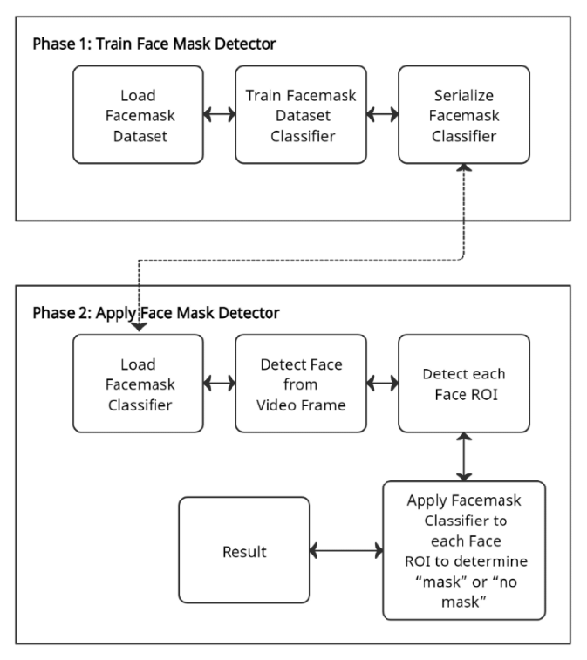

**RESULT:**

The result of the mask detection system is the identification of individuals who are not wearing masks in a given environment. This result is typically communicated through various means, depending on the system's configuration and integration with other systems. Some possible results and actions based on the detection outcome include:

**Alerts and Notifications:**

When an individual is detected not wearing a mask, the system generates alerts or notifications to notify relevant personnel or authorities. Alerts can be sent in real-time via email, SMS, or other communication channels to prompt immediate action.

**Visual Indicators:**

In some cases, the system may display visual indicators, such as color-coded warnings or overlays on surveillance camera feeds, to highlight individuals who are not wearing masks for easy identification by security personnel or monitoring operators.

**Audible Warnings:**

The system may also emit audible warnings or alarms to notify individuals not wearing masks and remind them to comply with mask-wearing policies. Audible warnings can serve as immediate prompts for corrective action.

Overall, the result of the mask detection system is the identification of individuals not wearing masks, which initiates appropriate actions to enforce mask-wearing policies, promote public health and safety, and ensure compliance with regulatory requirements.

**CONCLUSION:**

In conclusion, the development and implementation of mask detection solutions represent a crucial step in addressing public health concerns and enforcing mask-wearing policies in various environments. These solutions leverage advanced technologies such as computer vision, artificial intelligence, and real-time data analysis to automate the detection of individuals not wearing masks and facilitate prompt intervention and enforcement measures.

Key factors contributing to the success and adoption of mask detection solutions include technological advancements, regulatory mandates, organizational policies, and public health considerations. These solutions offer several benefits, including increased accuracy, real-time monitoring capabilities, integration with existing infrastructure, and compliance with privacy and data security regulations.

In summary, mask detection solutions play a vital role in the ongoing efforts to combat public health challenges, enforce mask-wearing policies, and safeguard communities against the spread of infectious diseases. By leveraging advanced technologies and collaborative initiatives, these solutions contribute to creating safer and healthier environments for individuals worldwide.

**PROGRAM:**

**!git clone https://github.com/misbah4064/face_mask_detection.git**

**%cd face_mask_detection**

**import cv2**

**import os**

**from tensorflow.keras.preprocessing.image import img_to_array**

**from tensorflow.keras.models import load_model**

**from tensorflow.keras.applications.mobilenet_v2 import preprocess_input**

**import numpy as np**

**from google.colab.patches import cv2_imshow**

**faceCascade = cv2.CascadeClassifier("haarcascade_frontalface_alt2.xml")**

**model = load_model("mask_recog.h5")**

**def face_mask_detector(frame):**

**# frame = cv2.imread(fileName)**

**gray = cv2.cvtColor(frame, cv2.COLOR_BGR2GRAY)**

**faces = faceCascade.detectMultiScale(gray,**

**scaleFactor=1.1,**

**minNeighbors=5,**

**minSize=(60, 60),**

**flags=cv2.CASCADE_SCALE_IMAGE)**

**faces_list=[]**

**preds=[]**

**for (x, y, w, h) in faces:**

**face_frame = frame[y:y+h,x:x+w]**

**face_frame = cv2.cvtColor(face_frame, cv2.COLOR_BGR2RGB)**

**face_frame = cv2.resize(face_frame, (224, 224))**

**face_frame = img_to_array(face_frame)**

**face_frame = np.expand_dims(face_frame, axis=0)**

**face_frame = preprocess_input(face_frame)**

**faces_list.append(face_frame)**

**if len(faces_list)>0:**

**preds = model.predict(faces_list)**

**for pred in preds:**

**(mask, withoutMask) = pred**

**label = "Mask" if mask > withoutMask else "No Mask"**

**color = (0, 255, 0) if label == "Mask" else (0, 0, 255)**

**label = "{}: {:.2f}%".format(label, max(mask, withoutMask) * 100)**

**cv2.putText(frame, label, (x, y- 10),**

**cv2.FONT_HERSHEY_SIMPLEX, 1, color, 2)**

**cv2.rectangle(frame, (x, y), (x + w, y + h),color, 3)**

**# cv2_imshow(frame)**

**return frame**

**input_image = cv2.imread("image.jpg")**

**output = face_mask_detector(input_image)**

**cv2_imshow(output)**

**input_image = cv2.imread("image2.png")**

**output = face_mask_detector(input_image)**

**cv2_imshow(output)**

**input_image = cv2.imread("image3.png")**

**output = face_mask_detector(input_image)**

**cv2_imshow(output)**

**input_image = cv2.imread("image4.jpg")**

**output = face_mask_detector(input_image)**

**cv2_imshow(output)**

**OUTPUT:**

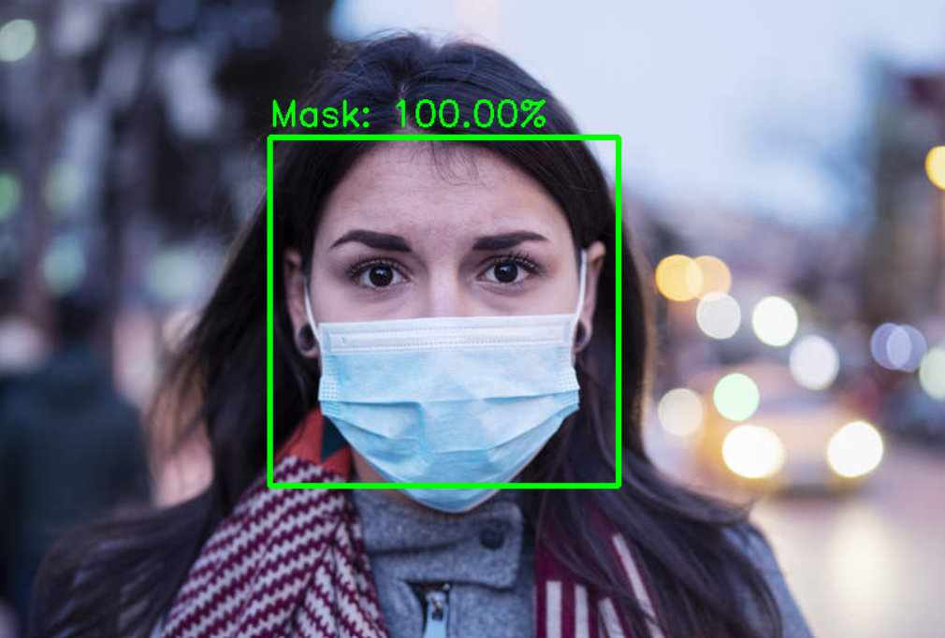

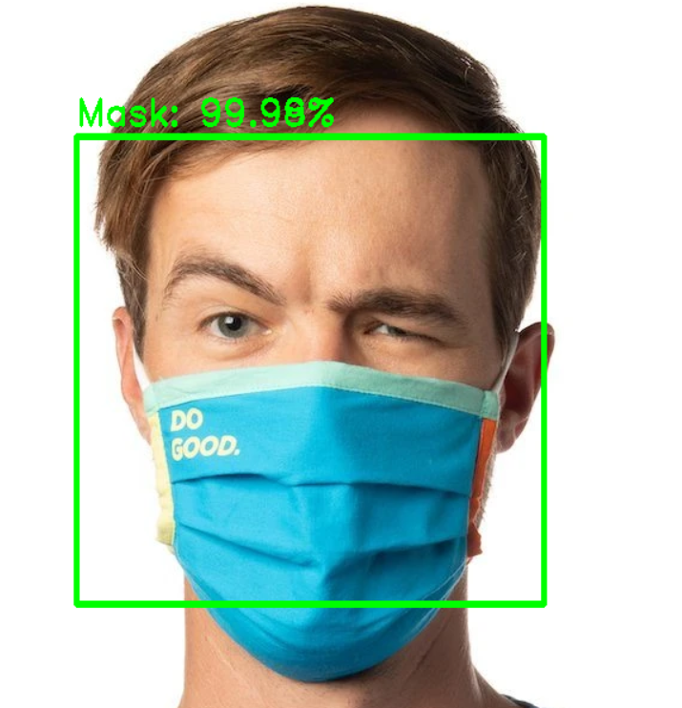

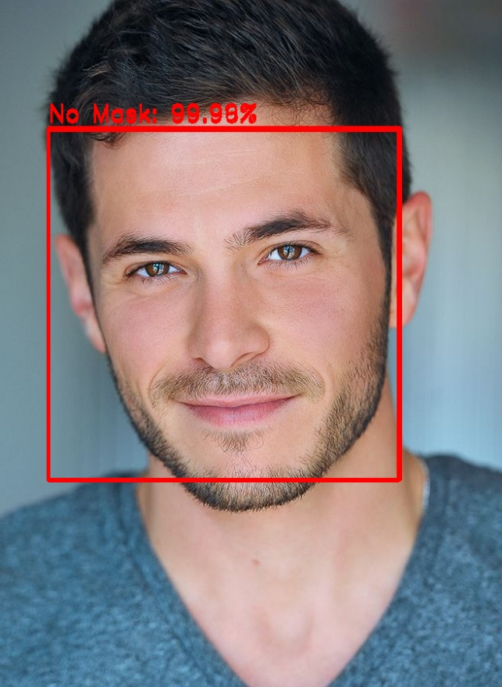

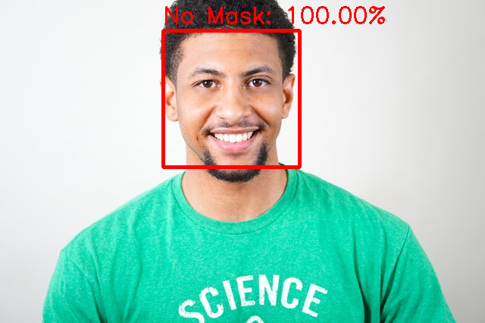

**REFERENCES:**

[1] OverFeat: Integrated Recognition, Localization and Detection using Convolutional Networks, 2014.

[2] D. Erhan, C. Szegedy, A. Toshev, D. Anguelov Scalable Object Detection using Deep Neural Networks Proceedings of the IEEE conference on computer vision and pattern recognition (2014), pp. 2147-2154, 10.1109/CVPR.2014.276.

[3] J. Redmon, S. Divvala, R. Girshick, A. Farhadi, You only look once: Unified, real-time object detection, in: Proceedings of the IEEE Computer Society Conference on Computer Vision and Pattern Recognition, 2016, vol. 2016-Decem, pp. 779–788, doi: 10.1109/CVPR.2016.91.

[4] M. Inamdar, N. Mehendale Real-Time Face Mask Identification Using Facemasknet Deep Learning Network SSRN Electron. J. (2020), 10.2139/ssrn.3663305.

[5] M. Inamdar, N. Mehendale Real-Time Face Mask Identification Using Facemasknet Deep Learning Network SSRN Electron. J. (2020), 10.2139/ssrn.3663305.

[6] S. Qiao, C. Liu, W. Shen, A. Yuille Few-Shot Image Recognition by Predicting Parameters from Activations Proceedings of the IEEE Computer Society Conference on Computer Vision and Pattern Recognition (2018), 10.1109/CVPR.2018.00755.

[7] A. Kumar, Z.J. Zhang, H. Lyu Object detection in real time based on improved single shot multi-box detector algorithm J. Wireless Com. Netw., 2020 (2020), p. 204, 10.1186/s13638-020-01826-x.

[8] World Health Organization et al. Coronavirus disease 2019 (covid-19): situation report, 96. 2020. - Google Search. (n.d.). <https://www.who.int/docs/default-source/coronaviruse/situation-reports/20200816-covid-19-sitrep-209.pdf?sfvrsn=5dde1ca2_2>.

[9] Social distancing, surveillance, and stronger health systems as keys to controlling COVID-19 Pandemic, PAHO Director says - PAHO/WHO | Pan American Health Organization. (n.d.). <https://www.paho.org/en/news/2-6-2020-social-distancing-surveillance-and-stronger-health-systems-keys-controlling-covid-19>.

[10] L.R. Garcia Godoy, et al. Facial protection for healthcare workers during pandemics: a scoping review, BMJ Glob. Heal., 5 (5) (2020), Article e002553, 10.1136/bmjgh-2020-002553

[11] S.E. Eikenberry, et al. To mask or not to mask: Modeling the potential for face mask use by the general public to curtail the COVID-19 pandemic Infect. Dis. Model., 5 (2020), pp. 293-308, 10.1016/j.idm.2020.04.001.

[12] L. Nanni, S. Ghidoni, S. Brahnam Handcrafted vs. non-handcrafted features for computer vision classification Pattern Recogn., 71 (2017), pp. 158-172, 10.1016/j.patcog.2017.05.025.

[13] Y. Jia et al., Caffe: Convolutional architecture for fast feature embedding, in: MM 2014 - Proceedings of the 2014 ACM Conference on Multimedia, 2014, doi: 10.1145/2647868.2654889.

[14] P. Sermanet, D. Eigen, X. Zhang, M. Mathieu, R. Fergus, and Y. Lecun, OverFeat: Integrated Recognition, Localization and Detection using Convolutional Networks, 2014.

[15] D. Erhan, C. Szegedy, A. Toshev, D. Anguelov Scalable Object Detection using Deep Neural Networks Proceedings of the IEEE conference on computer vision and pattern recognition (2014), pp. 2147-2154, 10.1109/CVPR.2014.276.